// **program to check positive or negative number**

class Check

{

public static void main(String args[])

{

int num = -10;

if(num>0)

{

System.out.println(num+" "+"is a Positive Number");

}

else

{

System.out.println(num+" "+"is a Negative Number");

}

}

}

**OUTPUT:**

**// program to check the eligibility for driving licence**

class licence

{

public static void main(String args[])

{

int age = 33;

if(age>=18)

{

System.out.println("Elegible for Driving Licence");

}

else

{

System.out.println("Not Elegible for Driving Licence");

}

}

}

**OUTPUT:**

**// Program to check whether the number is even or odd**

class OddOrEven

{

public static void main(String args[])

{

int num = 15;

if(num%2==0)

{

System.out.println("Number "+num+" is an Even number");

}

else

{

System.out.println("Number "+num+" is an Odd number");

}

}

}

**OUTPUT:**

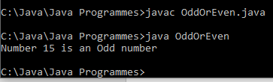

**// Program to find the largest among three numbers**

class LargestNum

{

public static void main(String args[])

{

int num1 = 500;

int num2 = 1500;

int num3 = 3;

if(num1>num2 && num1>num3)

{

System.out.println("Number "+num1+" is the largest number");

}

else if(num2>num3 && num2>num1)

{

System.out.println("Number "+num2+" is the largest number");

}

else

{

System.out.println("Number "+num3+" is the largest number");

}

}

}

**OUTPUT:**

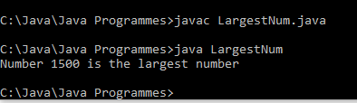

**// Program for finding grade of a student based on the marks**

class Grade

{

public static void main(String args[])

{

int mark = 75;

if(mark<40)

{

System.out.println("Student Failed");

}

else if(mark>=40 && mark<=60)

{

System.out.println("Student Passed with Grade D");

}

else if(mark>=60 && mark<=70)

{

System.out.println("Student Passed with Grade C");

}

else if(mark>=70 && mark<=80)

{

System.out.println("Student Passed with Grade B");

}

else if(mark>=80 && mark<=100)

{

System.out.println("Student Passed with Grade A");

}

else

{

System.out.println("Invaid mark");

}

}

}

**OUTPUT:**

